Ancient Egypt Project

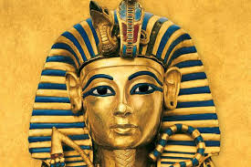

Project due: ___________
Egypt Project: 40 POINTS
Directions
In class, choose one of the following projects:
-Design a Sarcophagus
-Mummify an Apple
-Egyptian Burial Ceremony
-Create your own (w-permission)

To receive full credit, the following sections must be included in your project.
- Hieroglyphic Title Page – Your name must be written in hieroglyphic writing. Please also include (in English) on the bottom right hand corner, your name and class period. 5 points

- Written Summary – Regardless of which project you complete, please write a one-page summary of your chosen projects importance in Ancient Egypt. Information can be taken from the textbook but must also come from one other source. Please note your source at the end of your summary. 15 points

- Completed Project – Please bring your completed project to class. Your written project and any additional resources will be enclosed in a construction paper folder, given to you in class. 15 points

- Presentation - Be prepared to present your completed project and summary to the class on the date due. 5 points

